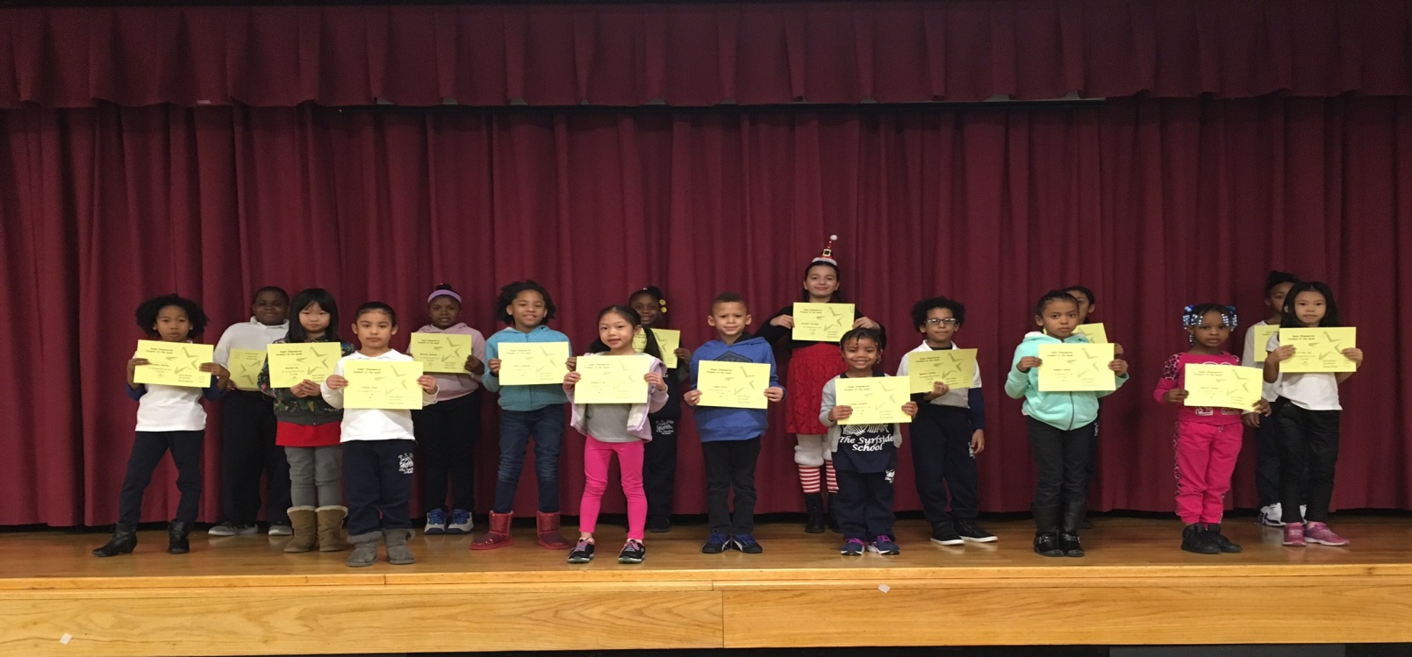
PRE K 131 | Leilani lockett
PRE K 145 | Gloriana Mcdew
PRE K 111 | Desire Lamar
K 138 | Abigail Alexander
K 147 | Jazlyn Cruz
K 140 | Makayla Lutchmansingh
1-113 | Logan Davis
1-134 | Ignacio Vielma
2-340A | Yiyun Tan
2-340B | Stephy Liao
3-234A | Rachel He
3-234C | Jesiyah Williams
4-322B | McCoya Samuels
4-322A | Kelis Johnson
4-322D | Shazeia Babb
5-334A | Doraly Diaz
5-334C | Amanda Castagno
K/1 133 | Chloe Fortunato
1/2 340C | Keysi Nunez
2/3 234B | Angela Clarke
3/4 322C | Brianna Clarke
4/5 334D | Kevin Senatus

Empowered Students the Week
12/16/16

