PRE K 131 | Lina Mangual
PRE K 145 | Alejandro Hudson Jr
PRE K 111 | Javeah Snipe
K 138 | Jamel Rosendary
K 147 | Jaelani Rodiguez
K 140 | Rosalia Rodriguez
1-113 | Elijah Copney
1-134 | Maurice Goode
2-340A | Jaden Nurkitt
2-340B | Jaylein Olvera
3-234A | Gabriella Ferrer
3-234C | Javon Johnnie
4-322B | William Rampersant
4-322A | Naser Abdulaziz
4-322D | Damani Dupree
5-334A | Keith Blunt
5-334C | Tony Lu
K/1 133 | Rasheed Bryant
1/2 340C | Ahmed Abdulaziz
2/3 234B | Jaheem Watson
3/4 322C | Josiah Grubb
2/3 334B | Heaven Bowe
4/5 334D | Kevin Senatus
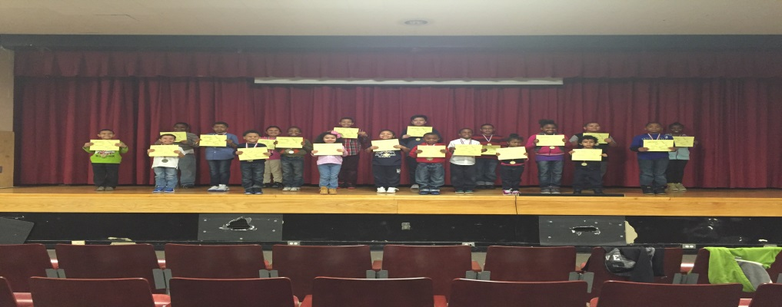

Empowered
Students of
the week.
Week of
3/10/17

