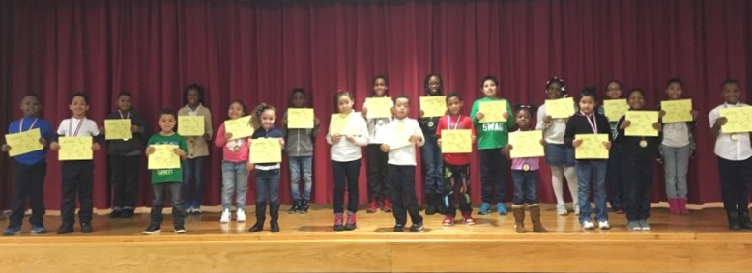
PRE K 131 | Desire Garrett
PRE K 145 | Thomas Turner
PRE K 111 | Melan Patterson
K 138 | Kevin Murph
K 147 | Adrianna Marquez
K 140 | Rosalia Rodriguez
1-113 | Ethan Gilkes
1-134 | Farihan Hossain
2-340A | Christopher O’campo
2-340B | Legend Davis
3-234A | Ciara Ramirez
3-234C | Karron Garret
4-322B | Shakai Grimes
4-322A | Kayla Watson
4-322D | Desire Hall
5-334A | Emanni Johnson
5-334C | Olannah Bedgood
K/1 133 | Isaiah Mundle
1/2 340C | Dieudonne Gibson
2/3 234B | Jordan Johnnie
3/4 322C | Deshawn Bowe
2/3 334B | Elizabeth Gibson
4/5 334D | Joseph Angerosa

Empowered Students of the Week

Week of 2/10/17

