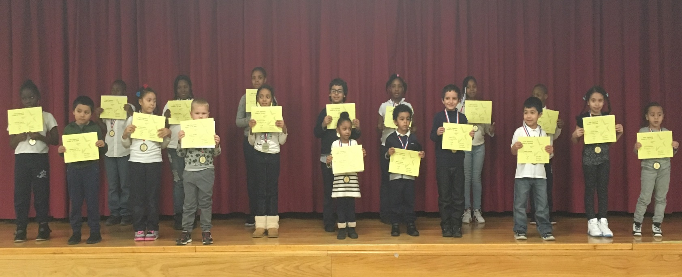
PRE K 131 | Skylar Danjou
PRE K 145 | Alexey Rodnov
PRE K 111 | Jaleeah Sebastian
K 138 | Cherly Jimenez
K 147 | Michael Tavarez
K 140 | Jaden Alvarado
1-113 | Madison Vasquez
1-134 | Anthony Martinez
2-340A | Dkhyrah Dupree
2-340B | Jubran Suhail
3-234A | Dhorey Colin
3-234C | Karim Alsaidi
4-322B | Jesenia Velez
4-322A | Aniyah Brown
5-334A | Kamaiya Braswell
5-334C | Kamiya Carrasco
K/1 133 | Rasheed Bryant
1/2 340C | Shaheim Hayden
2/3 234B | Elizabeth Gibson
3/4 322C | Jayden Minter
4/5 334D | Mikayla Capers

Week of 01/13/17

