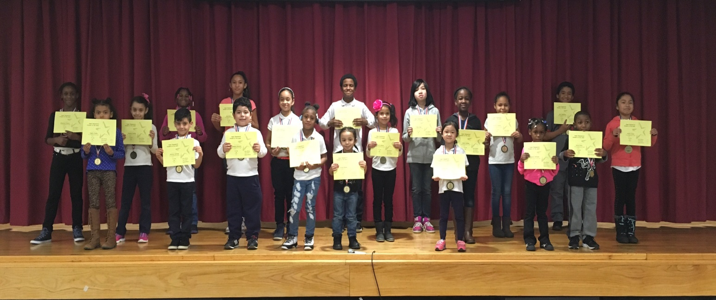

PRE K 131 | Jayson Reyes
PRE K 145 | Jayden Jr. Gray
PRE K 111 | Shaquasia Williams
K 138 | Kaliyah Reid
K 147 | Xander Allman
K 140 | Abbie Liao
1-113 | Dominick Baretto
1-134 | Nicholas Santiago
2-340A | Kayleen Grullon
2-340B | Chasity Garcia
3-234A | Yvette Cosme
3-234C | Serenity Thomason
4-322B | Golda Kankam
4-322A | Ana Olmedo Morales
4-322D | Aniya Maraj
5-334A | Andrea Skinner
5-334C | Jenny Deng
K/1 133 | N/A
1/2 340C | Koree Perez
2/3 234B | Kevin Applewhite
3/4 322C | Shamiece Fareira
4/5 334D | Kurtus Mckie
Week of 01/20/17

