PRE K 131 | Lina Mangual
PRE K 145 | Destiny Allen
PRE K 111 | Gabriel Lopez
K 138 | London Paris
K 147 | Kaylee Miranda
K 140 | Andy Chen
1-113 | Omari Marbury
1-134 | Laila Alford
2-340A | Destiny Cabrero
2-340B | Logan Rodiguez
3-234A | Majed Hassan
3-234C | Analisa Vestal & Leonardo Vielma
4-322B | Jordyn Philpot
4-322A | Luis Montero
4-322D | Surrani Franklin
5-334A | Kamyra O’Campo
5-334C | Jasmine Mesidor
K/1 133 | Rasheed Bryant
1/2 340C | Gabriella Soto
2/3 234B | Kayley Araujo
3/4 322C | Fiona Zou
4/5 334D | Jaylen Odom
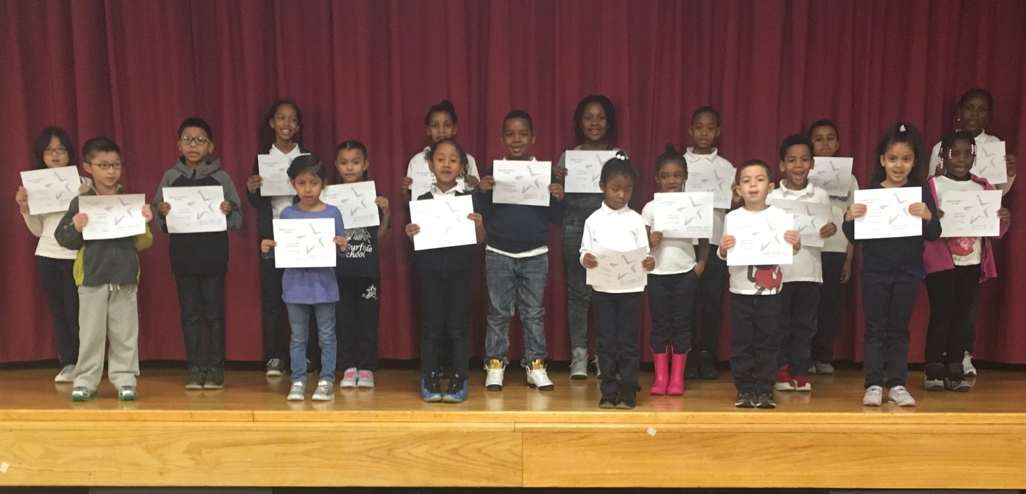

Empowered Students the Week
12/02/16

