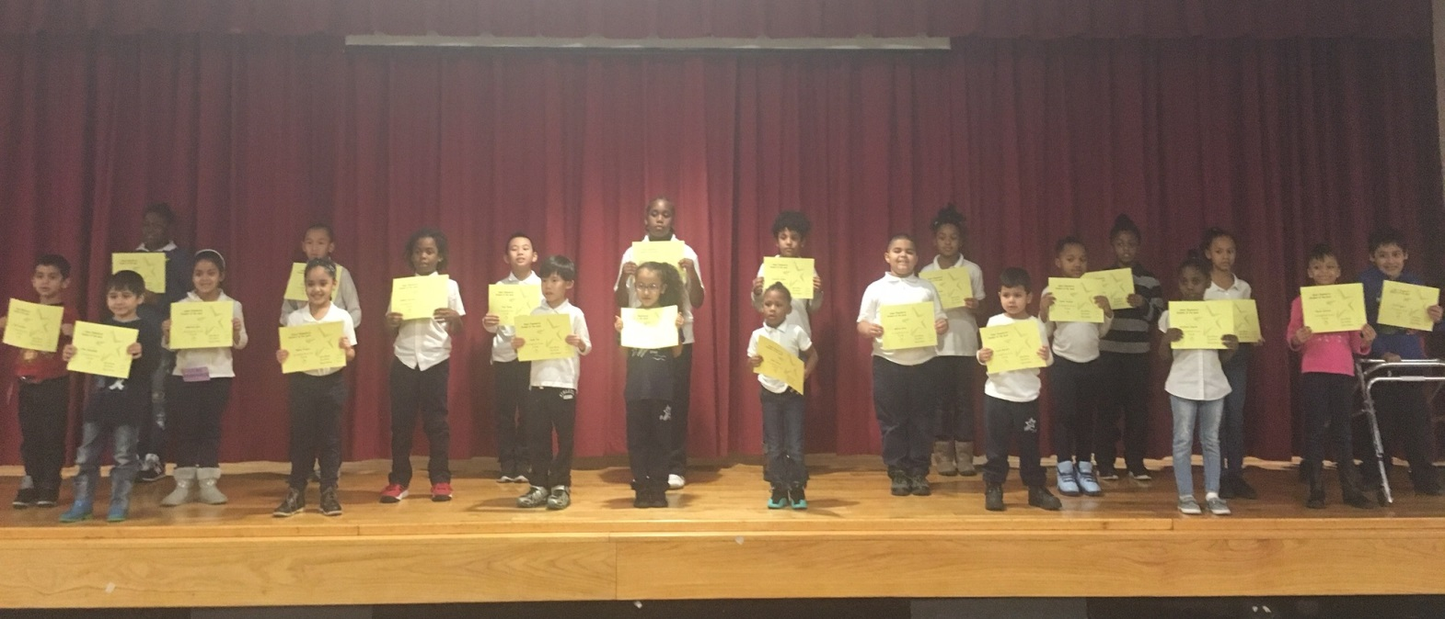
PRE K 131 | Lucas Barreto
PRE K 145 | Gibel Franco
PRE K 111 | Jada Vestal
K 138 | John Jamaladdin
K 147 | Krystyna Dupree
K 140 | Julius Castellano
1-113 | Yuxin Tan
1-134 | Janette Veliz
2-340A | Hailey Haddix
2-340B | Alyssa Stavrov
3-234A | Tyler Weng
3-234C | Leonardo Vielma
4-322B | Soloman Decoteau
4-322A | Mekhiah Rogers
4-322D | Shazeia Babb
5-334A | Er-Kong Lin
5-334C | Azari Springs
K/1 133 | Taniah Jackson
1/2 340C | Gabriela Soto
2/3 234B | Gabriel Soto
3/4 322C | Daishawn Watson
4/5 334D | Victor Rugerio

Week of 12/23/16

