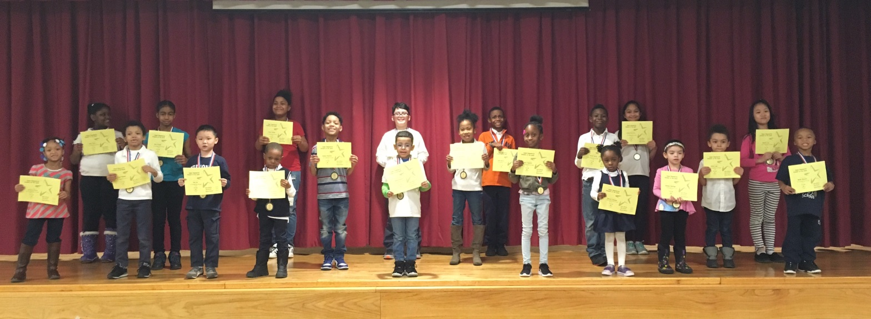
PRE K 131 | Rachel Clement
PRE K 145 | Savannah Goforth
PRE K 111 | Jordan Harris
K 138 | Kevin Lin
K 147 | Amare Scott
K 140 | Katelyn Santiago
1-113 | Blake Everett
1-134 | Dazaiya Augustin
2-340A | Kamauri Rayford
2-340B | Alex He
3-234A | Naima Lago
3-234C | Jayla Jones
4-322B | Eddie Aponte
4-322A | Asia Crooks
4-322D | Damon Myrick
5-334A | Sandra Zou
5-334C | Shemaiah Resurreccion
K/1 133 | Tyler Bennet
1/2 340C | Duriell Harris
2/3 234B | Brianna Clarke
3/4 322C | Kamani Walker
2/3 334D | Gabriel Morales Soto

Week of 01/27/17

